Study Guide
Directions: Answer each question. You don’t need to write in a complete sentence. Whenever you finish, you won’t turn this in.

- What is color used for on Physical Maps?

- What landforms are identified on Political Maps?

- What US Mountain Range stretches from Georgia to Maine?

- In the United States, why does most of the population live along the east coast, the west coast, and the Gulf of Mexico?

- What US region is known for its friendly hospitality?

- What US region is known for having the Wheat and Dairy Belt?

Use the climograph to answer questions 7-8.
Hilo, Hawaii
- Which month receives the lowest amount of precipitation?

- What is the approximate temperature for the month of December?

Use this map to answer questions 9-10.
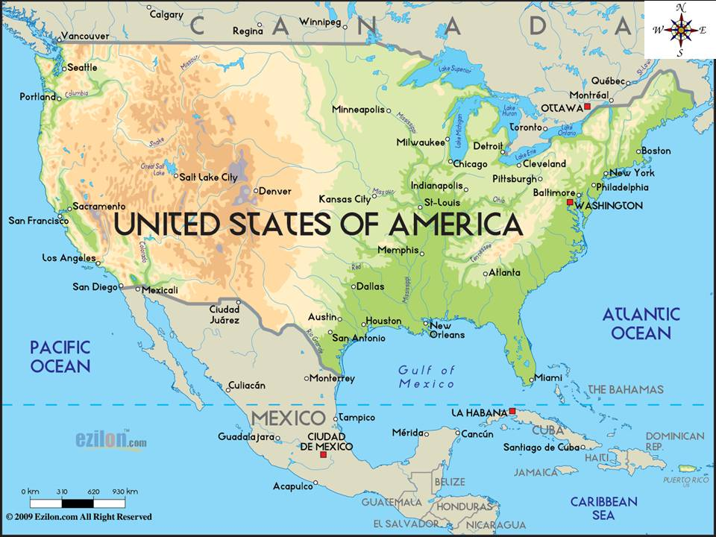

- What body of water is west of the US?

- What country is north of the US?

- How would Joplin be an example of a push factor?

- Why would the gold rush be an example of a pull factor?

- The most common natural disaster that hits cities in the south such as Miami or New Orleans is ________________________.

- List the 7 continents.

- List the 4 oceans.

- What is the largest lake in the world?

- Why would a tourist use a climograph?

- Why would a farmer use a climograph?

- 200 years ago, if you could build a trade city, what type of landform would you want to build it next to?

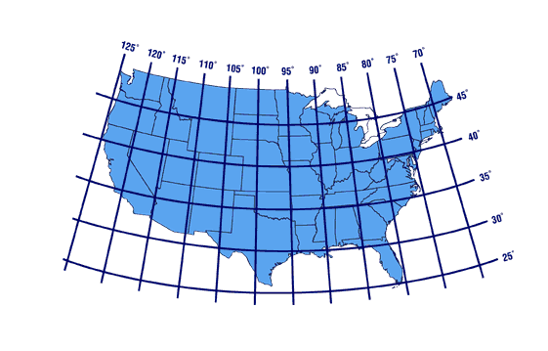
- What is the absolute location of Missouri?

- On what line is the equator located?

- Which of the following locations is a peninsula?

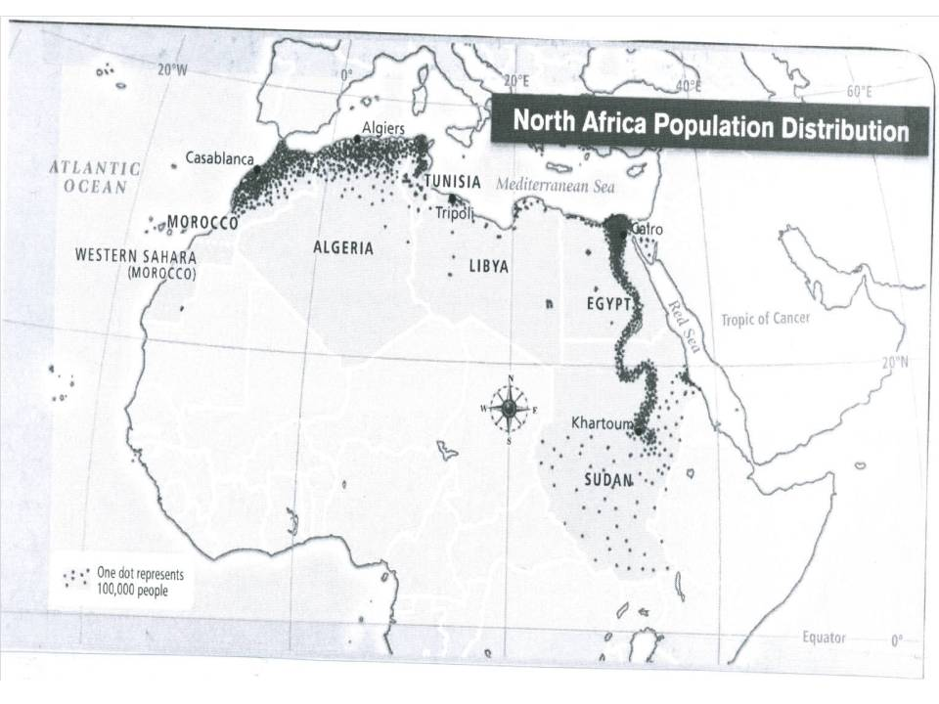

- What country in North Africa is the least populated?

- What do the most densely populated areas on the test have in common?

